Varying the output capacitor for a fixed input sine wave of 2.5V amplitude. The average power calculated using the mean function.

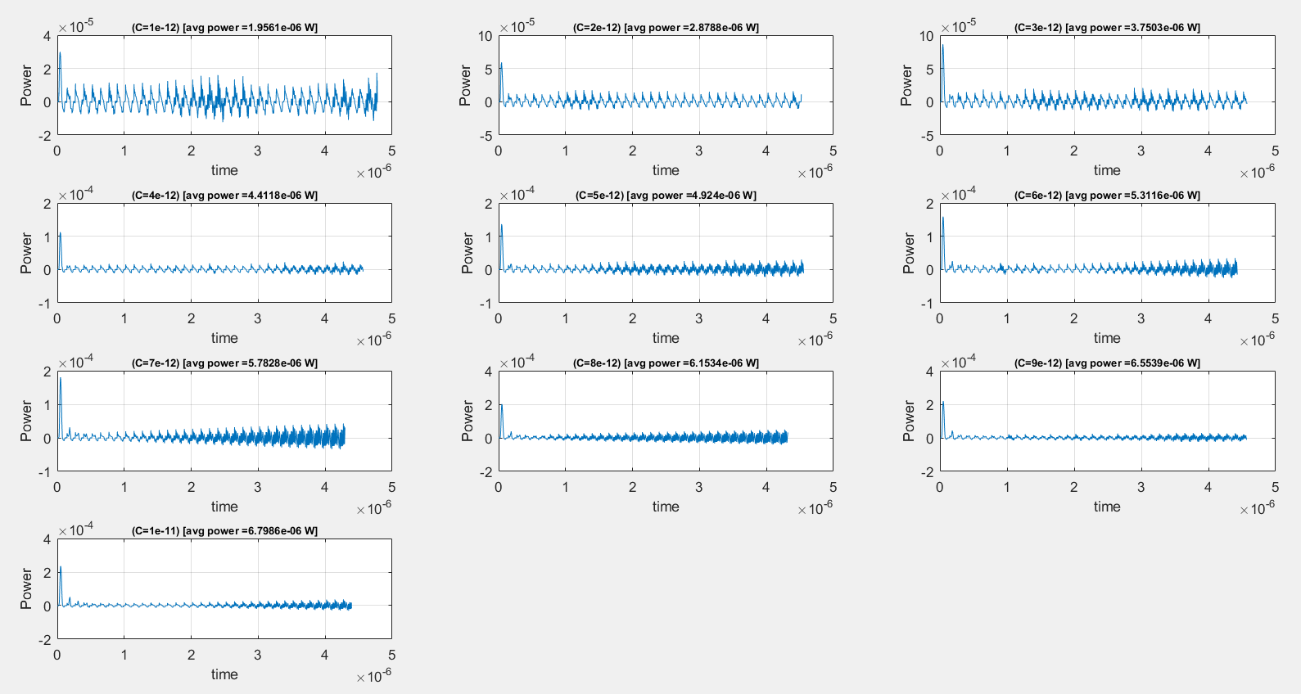



The points graphed after 1us to avoid the inclusion of spike when calculating the average power.

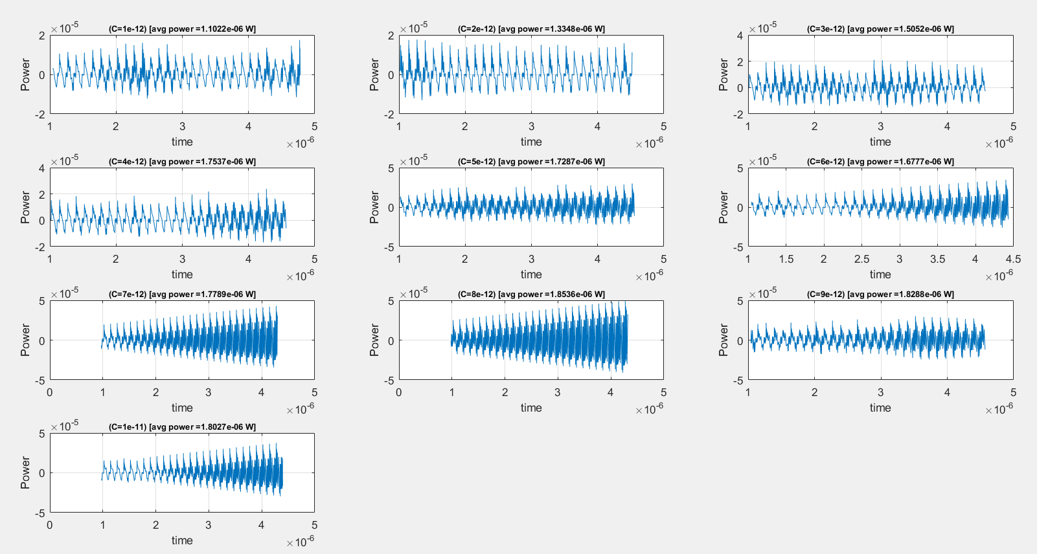



Average obtained using integration. Essentially integrate and divided by time interval to obtain average

Matlab trapz method was used.

avgpow = trapz(xval(startpt:1:endpt), yval(startpt:1:endpt))/(xval(endpt) - xval(startpt));

